3. Plot Data in Various Projections

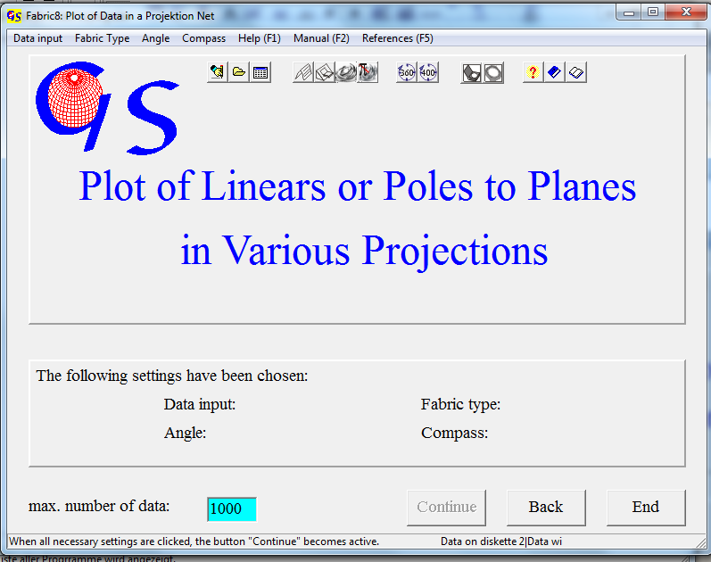
Fig. 1

This program (Fig. 1) plots orientation data in various projections.
Input can be manually, from a file, or from an excel sheet (Fig. 2).

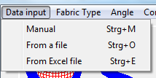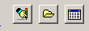
Fig. 2

The program also allows input of data measured with a Brunton compass. In the menu ‘Compass’ (Fig. 3) the data format is set. Data measured with the Clar-compass have the format 'direction of dip / angle of dip'. Input of data measured with the Brunton Compass is in 'strike / dip and dip direction’.

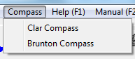 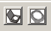 Fig. 3

With manual input the "Continue" button becomes acvtive after selection of "Data input", "Fabric type" and "Angle" and “Compass”. Manual input also includes direct input of azimuth and tilt-angle from a universal stage. Measures can be axes (i. e. quartz<c>axes) or normals to planes (i.e. normals to mica-planes). The program changes this type of data to azimuth and angle of dip. Output is in the same format. Manual input can be either in the 0-360° or in the 0-400°-scale.
Fig. 4 shows the form for input of dip direction and dip angle after pressing „Start“. When data input is finished, click the button “Terminate input”. This button activates the menus “Save data”, “Printer“, and “Plot“. “Plot” opens the graphic form.
Fig. 5 shows the form for input in the strike/dip format. These data are saved in the ‘dip direction / dip angle’ format.
The form for input from a file is also very similar to that of program1 and 2. Fig. 6 shows this form after clicking „Start“ and choice of a data file. Pressing the Button “Selection ok” puts the data of this file in the right list field and activates the menus “Save data”, “Erase file”, and “Printer“ menu.
Click “Erase file/Erase” and then click on a file name in the list to erase this file from the folder.
In the menu “Printer“ (Fig. 7) a data list can be printed or saved in a *.rtf-file. (Fig. 8).
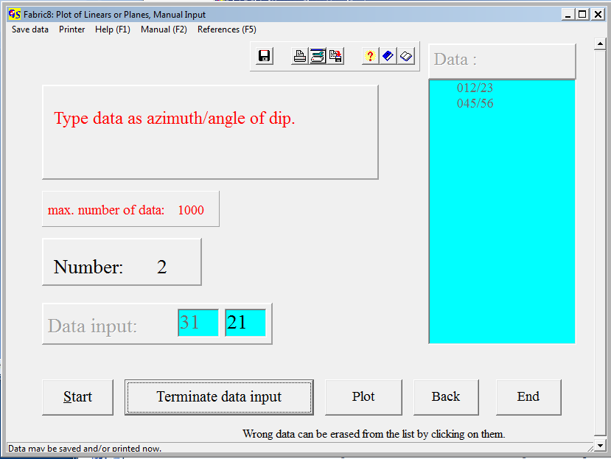Fig. 4

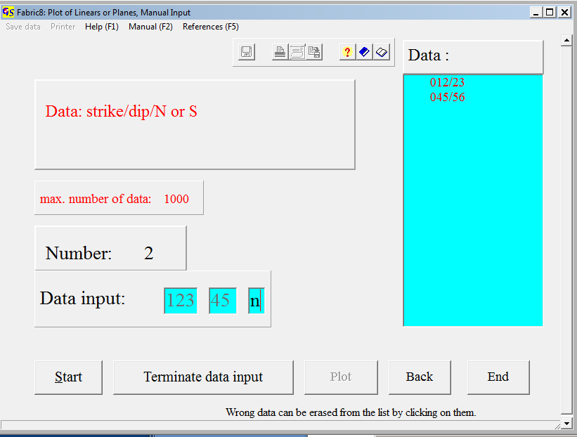 . Fig. 5

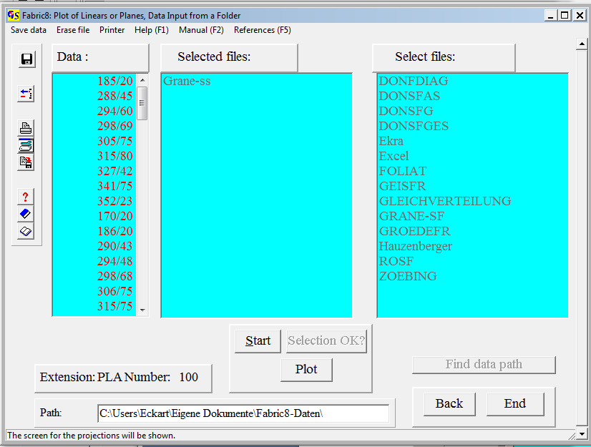
Fig..6

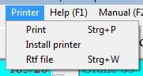
Fig. 7
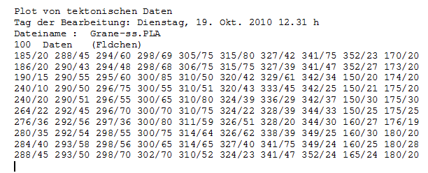Fig. 8

Data input from an excel file:
This option only runs when the task manager does not contain “Excel.exe“.
Pres the keys “Ctr”, “Alt”, and “Del” together to open the list of active programs in the task manager (Fig. 9).

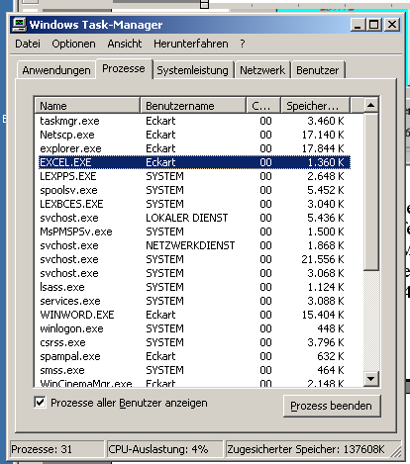
Fig 9

Press "Finish process" in order to close "Excel.exe“ and continue Fabric8. Fig. 10 shows the form for input from an excel file.

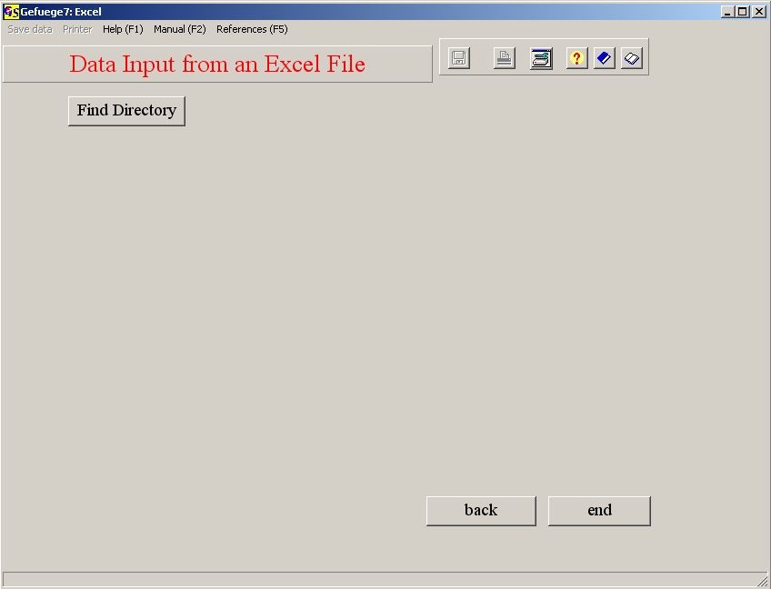 Fig. 10

Clicking on "Find directory" opens the window "Choose directory" (Fig. 11). Double click on the directory that contains the excel file and confirm with “OK”.

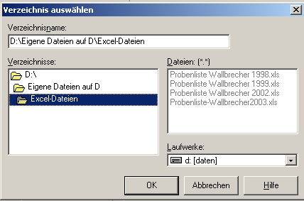
Fig. 11

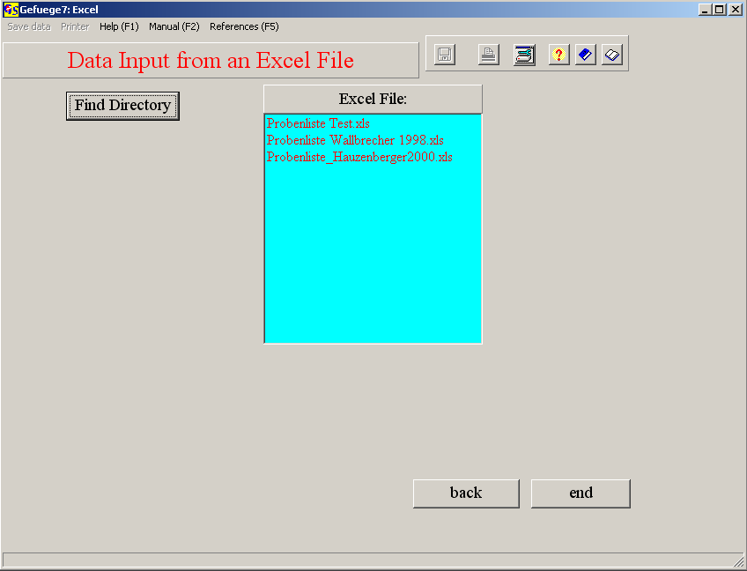
Fig. 12

The Excel-files of the chosen folder appear in the list 'Excel-File' (Fig. 12). Click on the file, you want to work with, and choose the worksheet that contains the data. Now an information appears that now the Excel- table will appear (Fig. 13). Clicking on 'OK' shows this Excel-table (Fig. 14). The table may contain azimuths and dip angles in two separate columns (columns j and k), or in one column with a separator-symbol (column l).

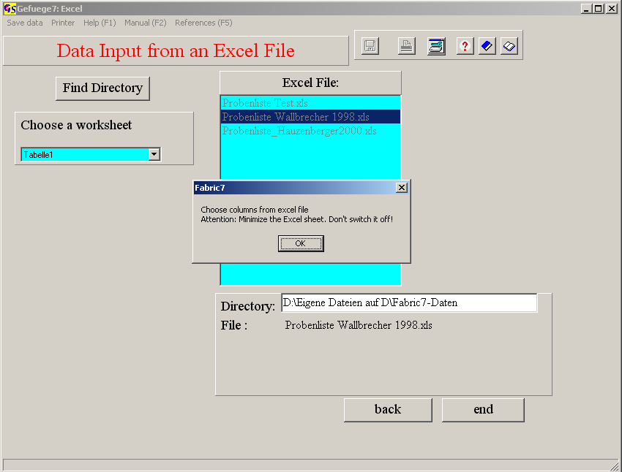
Fig. 13

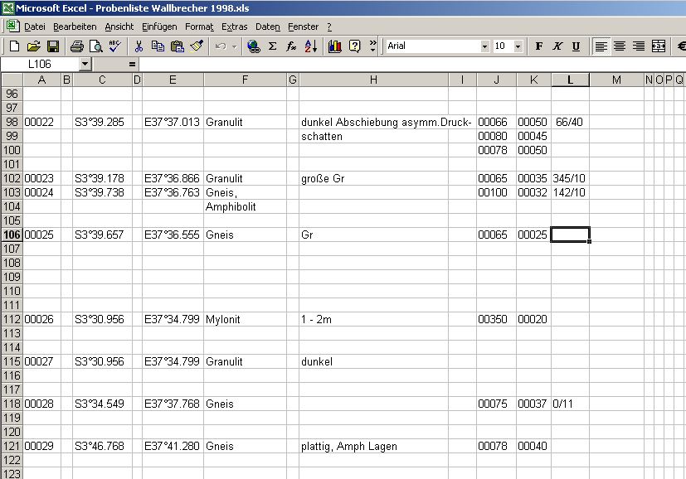
Fig. 14

Minimize the table, do not switch it off! Now the input field for the columns of azimuths and dip angles appear.

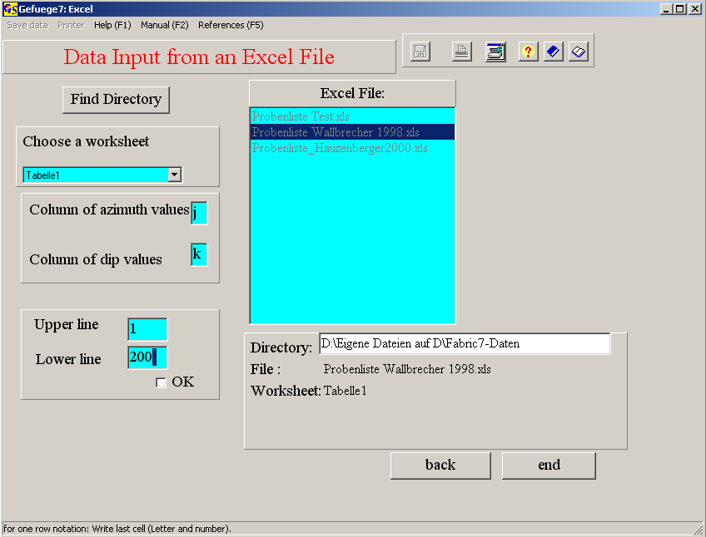
Fig.. 15

After input of the columns type the first and last row of for the data for which the diagram shall be plotted (Fig. 15). When azimuth and dip angle have the same columne, type the same letter twice and type the separator (Fig. 16).

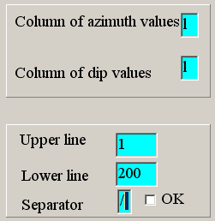
Fig. 16

When you click on "OK", the data appear in the list field and the number of data is indicated (Fig. 17). The Excel file may also contain data taken with a Brunton compass (strike, dio, direction of dip). These data may be written in one column (120/30N), in two columns (120 30N) or in three columns (120 30 N).

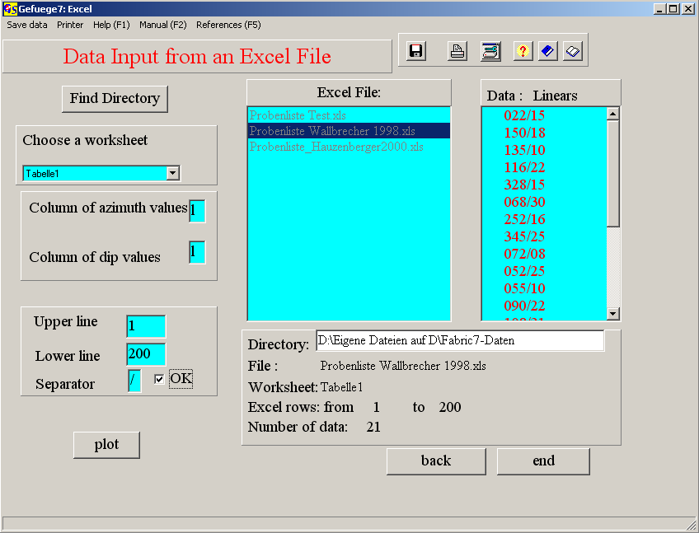
Fig. 17

Now the data can be saved and/or printed. With the button "plot" you open the graphic form.

Plot of the diagram:

Fig. 18 shows the graphic form after pressing the "Start" Button.
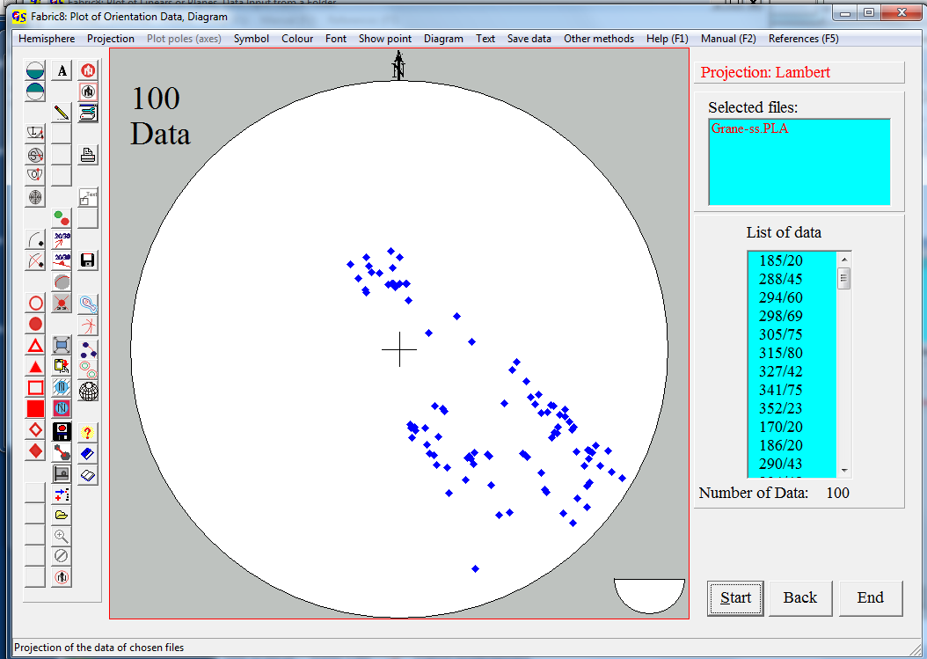Fig. 18

The settings of the menus "Hemisphere", "Projection", "Symbol", and "Colour" are saved in the file Fabric.ini. They can be changed at any time.
Menu Hemisphere (Fig. 19):
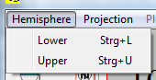
Fig. 19
In this menu you choose the projection of data in the lower (Fig. 18) or upper hemisphere (Fig. 20).

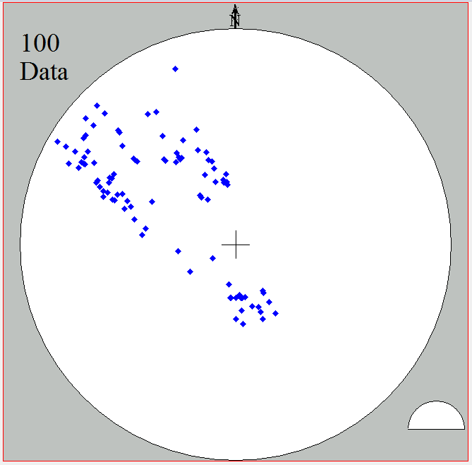Fig. 20

The choice of hemisphere is indicated by the symbol at the bottom on the right side.

Menu ‘’Projection’’ (Abb. 21):

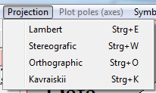
Fig. 21

Lambert Projection:
This projection (Fig. 22) is an equal area projection. It was introduced by Johann Heinrich Lambert (1728 – 1777).

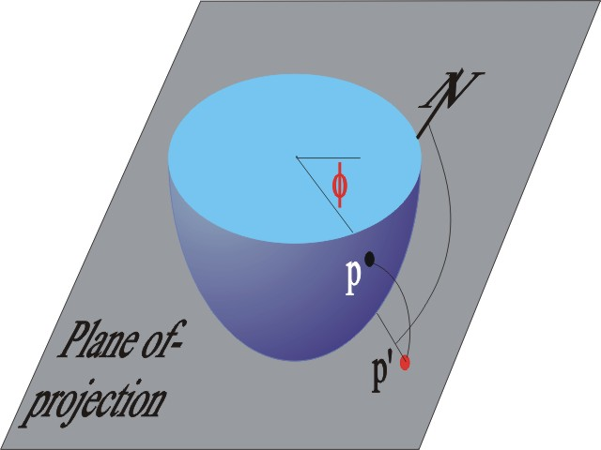Fig. 22
p = Point on the globe
p’ = Projected point
A net in this projection is the ‚Schmidt net’.

Stereographic Projection:
In this projection (Fig. 23) the equatorial plane is the projection plane. The projected point is the inersecting point of the line from the zenith to the point on the globe and the equatorial plane. The stereographic projection is a projection which does not change angles, it produces the Wulff net.

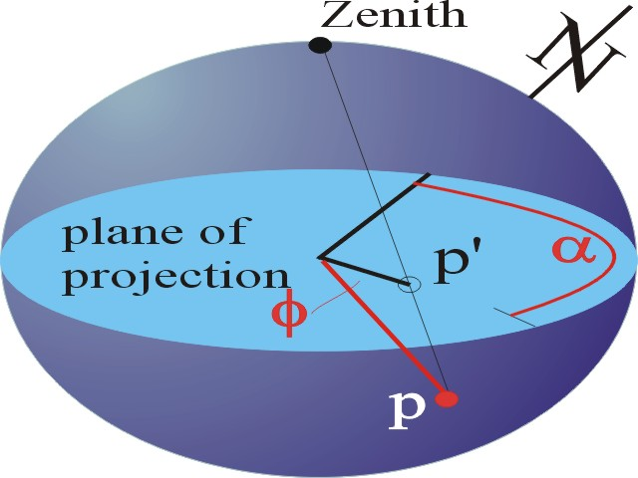 Fig. 23

P = point of the lineation on the globe
P’ = projected point

The orthographic projection:
The equatorial plane is the projection plane (Fig. 24). The points on the globe are projected orthogonically on the plane.
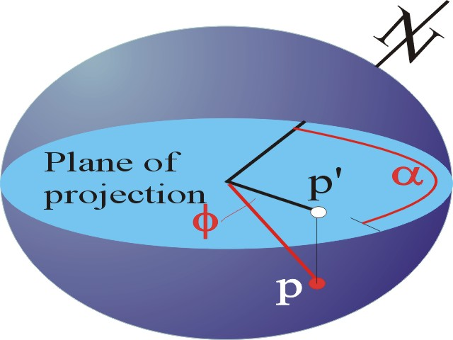Fig. 24

The Kavaraiskii-projection:
In this projection the distance (r) of the projected point from the centre is
r = (π − 2φ)/π.
φ = angle of dip
Menu ‘’Symbol’’:
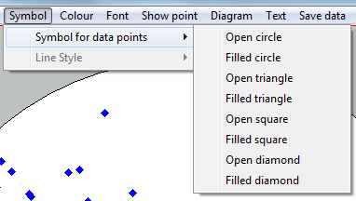 Fig.25

In this menu (Fig. 25) you choose the symbol for the data points.

Menu ‘’Colour’’ (Fig. 26):
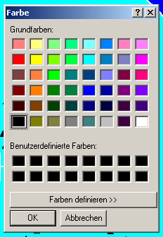 Fig. 26

In this menu you choose the colour of data point from the chart (Fig. 26).

With the menu "Show points" (Fig. 27) you can click on a point in the diagram.
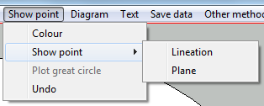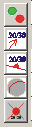
Fig. 27

The azimuth and angle of dip of this point is indicated (Fig.28). With "colour" you can choose the colour of the point and the script.
With clicking on “Lineation“ or “Plane“ the point is interpreted as a projection of a lineation or a plane. The measures of the point are shown in the chosen colour (Fig. 28). The option “Great circle” plots a great circle to the clicked point. For the option “Lineation“ the point is interpreted as pole to a plane and for the option “Plane” as dip lineation.
When “Show point/Lineation or Plane“ is chosen the measures of the point under the mouse cursor are shown in a window in the upper right corner of the diagram. This window is closed with the right mouse button. With “Undo” all measures are erased.

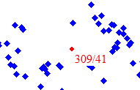
Fig. 28

The menu "Diagram" is shown in Fig. 29.

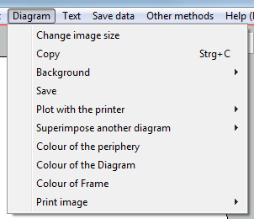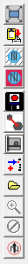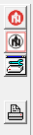
Fig. 29

The Option "Change size of saved image":
With this option you can change the number of pixels of the image. It opens the input field for image width and height (Fig. 30). High number increase the resolution of the saved image.
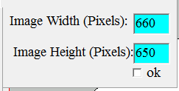
Fig. 30

The option "Copy" copies the actual graphic to the clipboard, so you can combine it with another drawing later.
With the option "Background" (Fig. 31) you cyn make the background transparent or you can choose a colour.

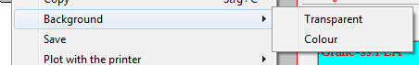
Fig. 31

Transparent background may be preferable when you only want to import the projection net and its content into another drawing (i.e. Autocad or CorelDraw).
A transparent graphic can only be saved in *.GIF format.

With the options "Save" and "Save under" (Fig. 32) you can export the plot into a graphic file.
The option “Save” opens a scrolling window (Fig. 32) with possible the graphic formats
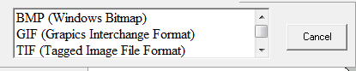
Fig. 32

Following formats can be chosen:
Windows Bitmap Format (*.BMP),
Compuserve Graphic Interchange Format (*.GIF).
Tagged Image File Format (*.TIF),
Jpeg Compression Format (*.JPG),
Windows Metafile Format (*.WMF),
Enhanced Windows Metafile Format (*.EMF).
Portable Network Graphic (*.PNG)

In addition two vectorgraphic formats can be used.

Hewlett Packard Graphic Language (*.PLT)
Drawing Exchange Format (Autocad) (*.DXF)

With these formats you can only save lines and dots and no coloured areas (background). The radius of the projection and the coordinates of the centre must be filled in the list which appears to the right side (Fig 33).

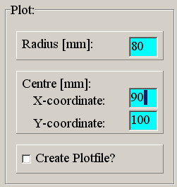
Fig. 33

These settings are saved in Fabric.ini by clicking on "Create plotfile", and the drawing is saved.
The option "Plot with a printer" prints the diagram as vectorgraphic.

The option “Superimpose another diagram” combines the actual diagram with another diagram which is already saved. You can inport *.BMP, *.GIF, *.TIF,
*.JPG, *.WMF, *.EMF, or *.PNG formats. Or the diagram can be pasted from the clipboard. With the option “Zoom” you can adjust the imported diagram to the size of the actual diagram (Fig. 34).

The option "Load from clipboard" combines a graphic already saved on the clipboard with the actual graphic.
The option "Load from file" combines the actual graphic with another graphic, saved in a file. The formats *.BMP, *.GIF, *,TIF, *.JPG, *.WMF und *.EMF can be imported (Fig. 34).
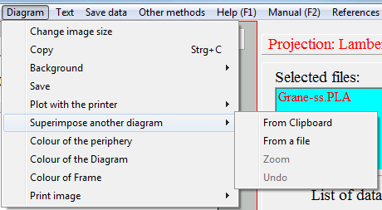
Fig. 34

The next options of this menu set the colours of the periphery of the diagram, of the area of the diagram and of the outer frame. All these settings are saved in Fabric.ini.

The option "Print image" prints a pixel graphic which is identical with the screen. The size of the graphic (radius) and position (X-,Y- coordinates oft he center point must be filled in the form of Fig. 35. They are saved in Fabric.ini. A caption of the graphic font size and position (right, middle, or left) must also be filled in.
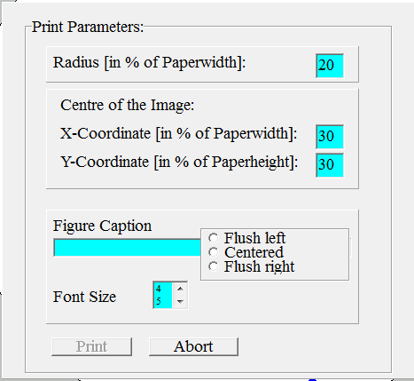
Fig. 35

With the menu „Text“ (Fig. 36) you can write a text in the diagram

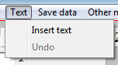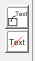
Abb. 36

After clicking on „Insert text“ an input window appaers at the bottom oft he graphic (Fig. 37). You can write any text and finish with “return”..

Abb. 37

Click with the left mouse button on the point in the diagram where the left upper corner oft he text shall appear (Fig. 38).

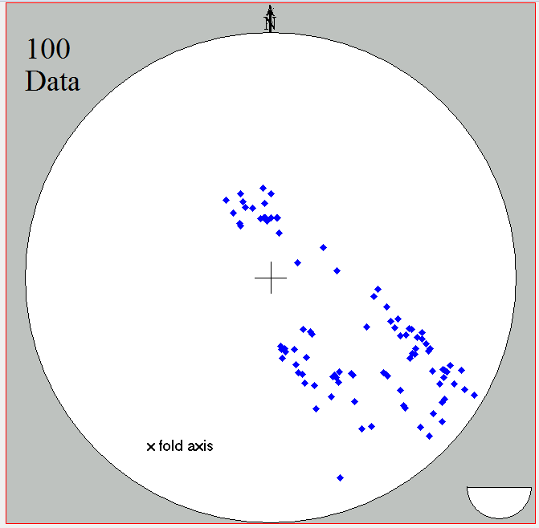
Fig. 38

Font style and size can be set in the menu „Font“.

With the menu "Other methods" (Fig. 39) you can jump to other programs which use the same data type.

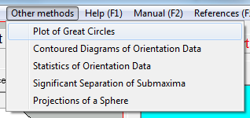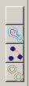

Fig. 39

